**FEB CBC ASSESSMENT 2024**

**GEOGRAPHY 273/1**

**TIME: 2 HOURS**

**Instructions:** Attempt **ALL** items.

1. East Africa has experienced a lot of changes in the weather and climate patterns in the recent years. The rainfall seasons have changed and temperature increase is high. The new climate patterns have caused a lot of suffering to people in terms of floods, famine due to crop failure, death of animals due to lack of pasture, outbreak pests like locusts, frequent landslides, difficulty in transport and poverty in various areas.

The governments of East Africa and the civil society organizations are trying to help people in the affected areas by giving handouts like food, financial donation, temporary shelter, medicine among others to reduce the suffering of the communities. However, these interventions look to be short term and not long term because climate is still changing.

Task:

Write detailed information to the people of your country on how they can overcome the challenges in the scenario above.

2. The government has discovered minerals in your area and it wants to start the extraction and establish a processing industry. However, the people who have lived in the area are against the government project because their land is a source of their livelihood in terms of agriculture, hunting and food gathering, wood products, settlement and fishing. The members of the community are mobilizing themselves to fail government efforts in all ways. The government officials have been asked to meet with the members of the community to find a way of how to sensitize them about the government project.

**Support:**

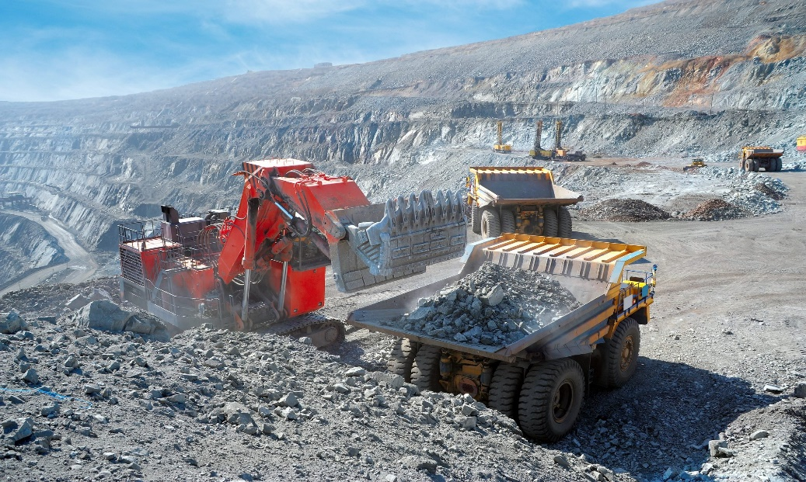

Task:

Write a sensitization message of not more than 500 words the government officials will present to the community members in the meeting

3. The population of Uganda is growing at an average speed of 3.3%. This is seen by large number of the youth, congestion in social amenities like schools, increasing cost of living, poverty, increase in labour export, growth of trade and towns among others. Calls have been made by religious, political leaders and civil society for people to find a way of how they can reduce on the growing population. However, these calls have been ignored as seen by the high birth rates, early marriages, and a souring number of expectant mothers seeking maternity help in health facilities. The government is therefore, looking for experts to find a lasting solution to exploding population.

Table showing the population of Uganda between 2017-2022

|  |  |  |
| --- | --- | --- |
| **YEAR** | **TOTAL POPULATION** | **GROWTH RATE** |
| 2017 | 40,127,085 | 3.56 |
| 2018 | 41,515,395 | 3.46 |
| 2019 | 42,989,080 | 3.45 |
| 2020 | 44,404,611 | 3.39 |
| 2021 | 45,583,778 | 3.26 |
| 2022 | 47,249,585 | 3.04 |

***Source: Unite Nations World Population Prospects, UNDP Report 2023 pg 104***

Task:

1. Draw a suitable graph showing the information in the table above.
2. Prepare a paper of not more than 500 to be presented to the government addressing the issue in the scenario above.

**END**